 Project Report

TITLE: 3D Printer Material Prediction Using IBM Watson Studio

By:

1. Abhinav Srivastava- 20BCY10211
2. Sai Gayatri- 20BBS0071
3. Shubham Gupta-20BAI10359
4. Supreetha Katta- 20BBS0195

# 1 INTRODUCTION

* 1. Overview

Our project involves the prediction of 3D Printer Material using IBM Watson Studio. The method of 3D printing entails building up successive layers of material to produce three-dimensional items from a computer design.

The final quality and properties of the printed object are greatly influenced by the material choice utilised in 3D printing. In 3D printing, material prediction seeks to choose the best material for a certain printing task by taking into account elements like strength, durability, flexibility, cost, and other particular criteria.

The best material for a given 3D printing project can be predicted using numerous criteria and data science techniques like machine learning and predictive modelling. A cloud-based platform called IBM Watson Studio gives data scientists the tools and features they need to create and use machine learning models. It provides a collaborative setting for model training, deployment, and data preparation.

* 1. Purpose

The goal of the project: 3D printer material prediction using Watson Studio, can change depending on the particular objectives and specifications established by your team or organisation. However, the following are a few typical goals for such a project:

1. Material Optimisation: By anticipating the best material for a certain printing assignment, the research intends to optimise the 3D printing process. The project can assist customers in selecting materials intelligently by utilising data science approaches and machine learning models, which will increase print quality, cost effectiveness, and efficiency.
2. User assistance: The project can help users who are not familiar with various materials' qualities in the context of 3D printing. The application can assist users in selecting the best content for their unique needs by making recommendations based on user criteria, improving the user experience and minimising trial and error.
3. Resource Management: For enterprises, effectively managing 3D printing resources, such as material stock, might be essential. By recommending substitute materials that satisfy the required criteria when certain materials are unavailable or in short supply, the project can aid in resource optimisation. By doing this, the printing process may be made more efficient and production bottlenecks can be avoided.
4. Decision Support: The project can act as a system to assist those working in the 3D printing sector in making decisions. The programme can offer helpful insights and recommendations for material selection by utilising data analysis and predictive modelling, assisting users in making selections based on aspects like cost, performance, availability, and environmental impact.

The overall goal of this project is to improve 3D printing by utilising data science approaches and web development to provide precise material predictions and suggestions, facilitate informed decision-making, and maximise resource utilisation.

**2 LITERATURE SURVEY**

2.1 Existing problem

The existing problem in the field of 3D printer material prediction revolves around determining the most suitable material for a given 3D printing task. The choice of material significantly impacts the final quality, strength, flexibility, cost, and other characteristics of the printed object. However, manually selecting the optimal material can be time-consuming, resource-intensive, and prone to trial and error. To address this problem, researchers and practitioners have employed various approaches and methods. Here are a few existing approaches and methods used to solve the problem of 3D printer material prediction:

1. Data-driven Approaches:
2. Machine learning: In order to create prediction models, researchers have used machine learning approaches to analyse historical data, such as material qualities, printing settings, and performance measures. These models can then be used to suggest materials in accordance with particular printing needs.
3. Convolutional neural networks (CNNs) and recurrent neural networks (RNNs) are two examples of deep learning models that have been used to accurately forecast materials by extracting complex patterns and relationships from big datasets.
4. Optimization Algorithms: To find the ideal mixture of printing parameters and materials, optimisation algorithms can be used, such as genetic algorithms or particle swarm optimisation. These algorithms are capable of efficiently exploring the solution space and determining the optimum material options.

2.2 Proposed solution

The development and application of a predictive model that can suggest the best material for a certain 3D printing task is usually the suggested approach for 3D printer material prediction. The process of choosing materials will be automated and streamlined using data science techniques. For this issue, the following techniques or answers can be suggested:

a) Classification Models: Utilize classification algorithms (e.g., decision trees, random forests, support vector machines) to categorize materials into different classes based on their characteristics and properties. The model can then recommend the class of materials that align with the desired specifications.

b) Model Evaluation and Validation: Employ appropriate evaluation metrics, such as accuracy, precision, recall, or mean squared error, to assess the performance of the predictive model. Use validation techniques like cross-validation or hold-out validation to ensure the model's robustness and reliability.

# 3 THEORITICAL ANALYSIS

3.1 Block diagram

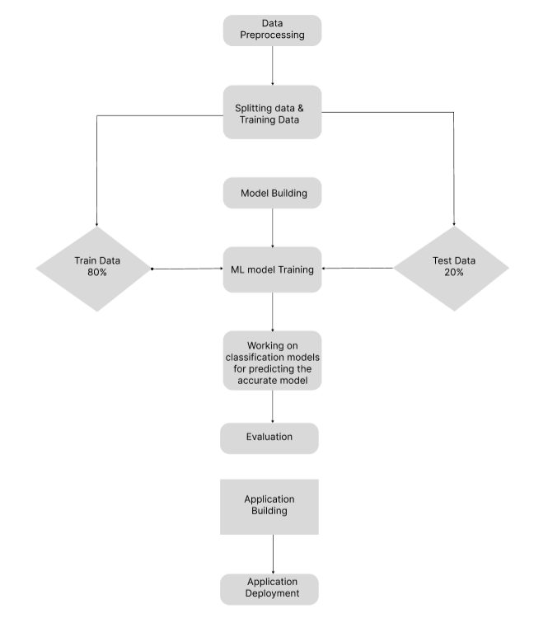

* 1. Hardware / Software designing

Hardware Requirements:

Computer: A standard computer with sufficient processing power and memory to handle the data analysis, modeling, and development tasks involved in the project.

Storage: Adequate storage capacity to store datasets, models, and any other necessary project files.

GPU (optional): If you plan to use deep learning models that benefit from GPU acceleration, having a compatible GPU can significantly speed up the training process. However, this is not a strict requirement and can depend on the scale and complexity of your project.

Software Requirements:

Python: The project will likely be implemented using the Python programming language, so ensure that Python is installed on your computer.

IBM Watson Studio: To utilize the data science capabilities of IBM Watson Studio, you'll need to sign up for an IBM Cloud account and set up a Watson Studio instance.

Flask: Install the Flask framework to develop the web application component of your project. You can use the pip package manager to install Flask.

Data Science Libraries: Install Python libraries such as NumPy, Pandas, Scikit-learn, TensorFlow, or PyTorch to perform data analysis, machine learning, and deep learning tasks.

IDE or Text Editor: Choose an Integrated Development Environment (IDE) or a text editor of your preference to write and manage your code. Popular options include PyCharm, Visual Studio Code, Jupyter Notebook, or Sublime Text.

1. **EXPERIMENTAL INVESTIGATIONS**

The development and application of a predictive model that can suggest the best material for a certain 3D printing task is usually the suggested approach for 3D printer material prediction. The process of choosing materials will be automated and streamlined using data science techniques. For this issue, the following techniques or answers can be suggested:

Data Exploration and Preprocessing: Perform exploratory data analysis (EDA) to understand the distribution, range, and relationships between different material properties and printing parameters. Analyze the dataset for missing values, outliers, or inconsistencies that may require data preprocessing steps such as imputation, normalization, or feature scaling.

Model Performance Evaluation: Evaluate the performance of the decision tree classification model using appropriate metrics such as accuracy, precision, recall, F1-score, or area under the ROC curve (AUC-ROC). Compare these metrics against a baseline or other models to assess the effectiveness of the decision tree approach.

Cross-Validation: Perform cross-validation to estimate the model's generalization performance and assess its stability. Split the dataset into multiple folds, train and evaluate the model on different fold combinations, and calculate the average performance metrics to ensure reliable results.

Comparison with Other Models: Compare the performance of the decision tree model with other classification algorithms, such as random forests, support vector machines (SVM), or neural networks. This analysis can help identify whether the decision tree model provides superior predictive capabilities in the context of 3D printer material prediction.

By conducting these experimental investigations and analyses, you can gain a deeper understanding of your solution's performance, its strengths, and areas for improvement. These investigations also allow you to validate the effectiveness of the decision tree classification model in predicting optimal 3D printer materials.

1. **FLOWCHART**

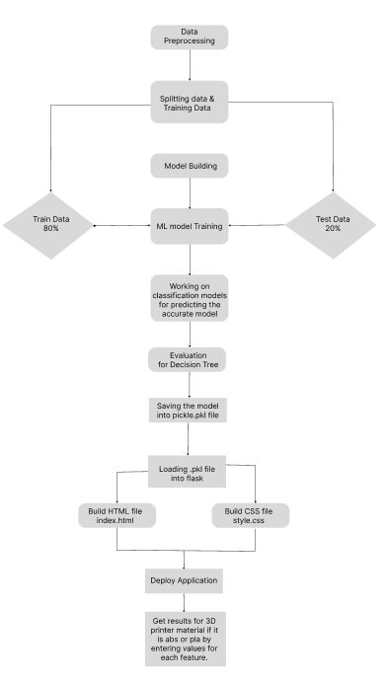

1. **RESULT**

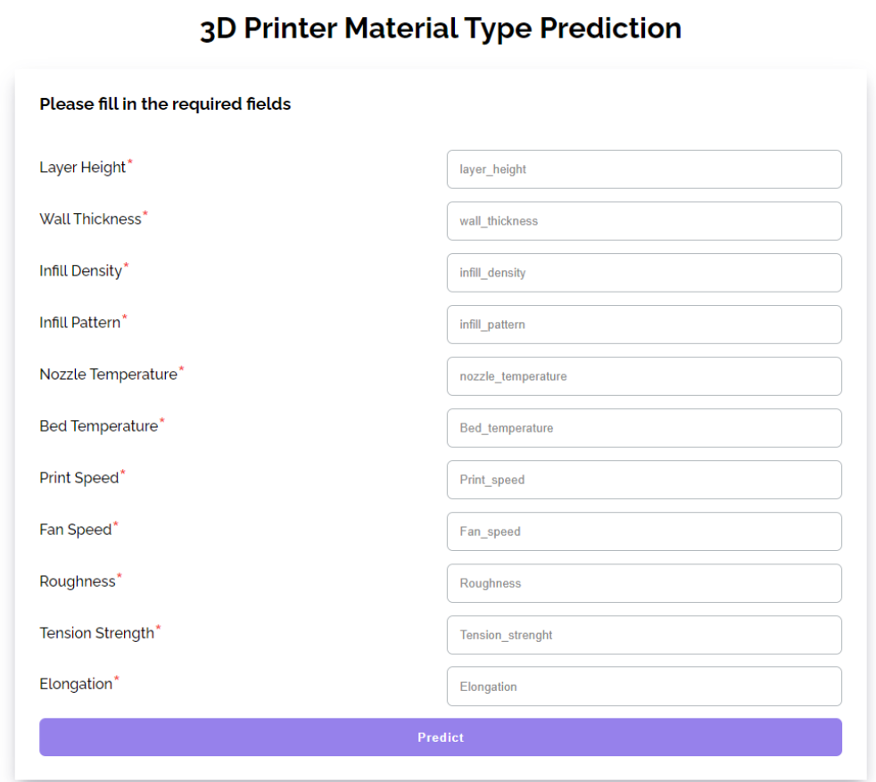

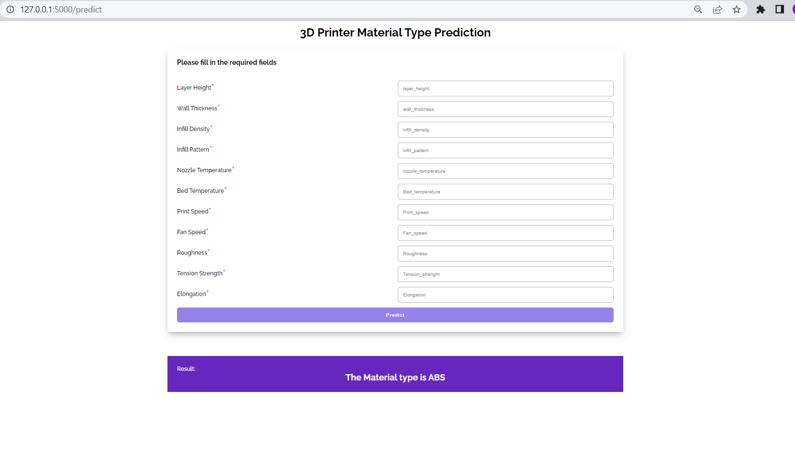

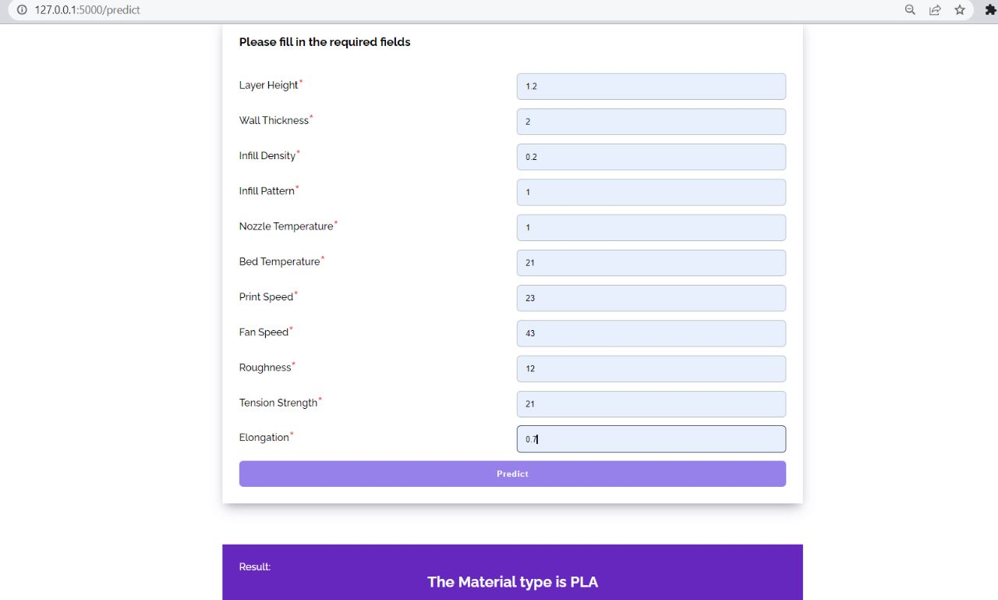

1. **ADVANTAGES & DISADVANTAGES**

The proposed solution for 3D printer material prediction using a decision tree algorithm offers several advantages. By utilizing classification models, such as decision trees, the process of selecting materials for 3D printing tasks can be automated and streamlined. The model takes into account the characteristics and properties of different materials, categorizing them into classes based on their specifications. This data-driven approach enables objective and evidence-based material recommendations, saving time and effort for users. Additionally, decision tree algorithms provide interpretability, allowing users to understand the reasoning behind the suggested materials. The transparency offered by decision trees builds trust and confidence in the recommendations. However, the proposed solution also has some disadvantages to consider. Decision trees may struggle to capture complex relationships and interactions among material properties, potentially oversimplifying the decision rules. Overfitting can be a concern, necessitating careful parameter tuning and regularization techniques. Effective feature engineering is crucial for accurate predictions, requiring domain knowledge and expertise. Data availability and quality, including bias and missing values, can impact the model's performance. Considering these advantages and disadvantages, the proposed solution can provide valuable insights and recommendations for material selection in 3D printing, but it is important to address the limitations and challenges to ensure reliable and accurate predictions.

1. **APPLICATIONS**

A 3D printer material prediction website offers numerous practical applications in the real world. It streamlines the material selection process for 3D printing, enabling manufacturers to identify the optimal materials for their specific printing requirements. Researchers and scientists can benefit from the website by receiving suggestions on material compositions to achieve desired properties for their projects. Designers and engineers can utilize the platform to explore various material options, facilitating informed decisions for prototyping and design validation. Moreover, the website supports personalized manufacturing by recommending suitable materials for customized products. It serves as an educational tool, allowing students and enthusiasts to experiment with different material combinations and gain insights into their impact on printed object properties. Additionally, the website aids in material optimization, recycling, and sustainability efforts by suggesting applications for recycled materials and promoting a circular economy approach. Overall, this technology-driven platform accelerates innovation, efficiency, and advancement in the field of 3D printing.

1. **CONCLUSION**

In conclusion, the project focused on developing a predictive model for 3D printer material prediction using machine learning techniques, specifically utilizing the Decision tree algorithm. The goal was to automate and streamline the process of selecting the best material for a given 3D printing task.

Through the implementation of the Decision tree algorithm, the project leveraged the power of data science to categorize materials based on their properties and characteristics. This approach provided several advantages, including automation, data-driven decision-making, scalability, and interpretability. The model enabled faster and more objective material selection, saving time and effort for users.

By utilizing Flask, the model was deployed, allowing for easy integration into existing systems or as a standalone web application. The Flask framework provided a robust and scalable platform for users to input their desired material specifications and receive accurate recommendations.

Throughout the project, considerations were made regarding the advantages and disadvantages of using the Decision tree algorithm. While decision trees offer interpretability and ease of implementation, they may struggle with complex relationships and overfitting. Proper feature engineering, data quality, and parameter tuning were essential to mitigate these challenges and ensure accurate predictions.

Overall, the project demonstrated the feasibility and effectiveness of utilizing machine learning, specifically the Decision tree algorithm, for 3D printer material prediction. The deployed Flask application provided a user-friendly interface for users to access the material recommendations, enhancing the efficiency and accuracy of material selection in the 3D printing domain.

# 10 FUTURE SCOPE

The future scopes of this project include improving accuracy through refined feature selection and optimized algorithms, incorporating advanced features like material composition and microstructure, addressing multi-material printing challenges, and exploring techniques such as data augmentation and fusion. Additionally, researchers can investigate uncertainty estimation, integration with simulation and optimization, real-time decision making, and transfer learning. These advancements can enhance the efficiency and effectiveness of material selection in 3D printing, facilitating informed decision-making and enabling the utilization of novel materials and printing processes.

# 11 BIBILOGRAPHY

1. <https://www.kaggle.com/code/shubhamgupta012/3d-printer-material-prediction>
2. [https://smartinternz.com/Student/guided_project_info/524516#](https://smartinternz.com/Student/guided_project_info/524516)

# APPENDIX

A. Source Code

<https://github.com/Supreetha-02/3D-Printer-Material-Prediction>